Management of the publicly owned wildlife resource must not remain in the hands of a privileged miniscule population. Wildlife, under the control of special interest hunters, is not being managed for the public benefit-- the crucial mandate of the PUBLIC TRUST DOCTRINE.

This 100% control by the 1% hunter population constitutes illegal ownership. In the hunters’ self- interest, wildlife is managed for excess inventory for shootable surplus. This insures hunter success, satisfaction, retention, recruitment and the continual sale of hunting licenses to generate revenue. All serve to perpetuate the “sport” and culture of recreational hunting..
.
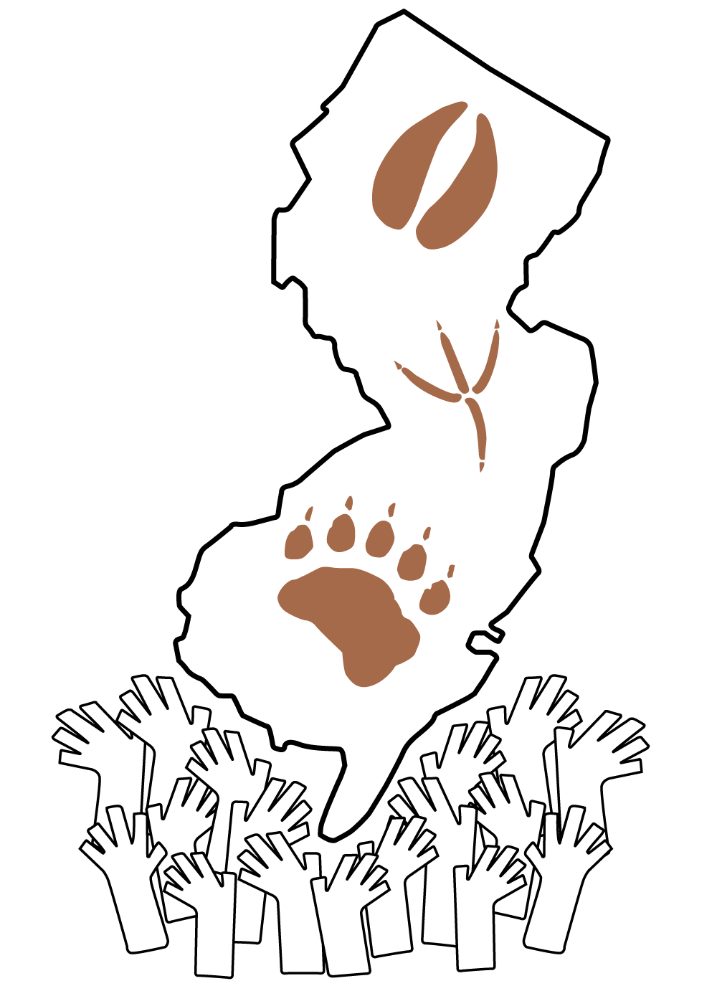

PUBLIC TRUST
WILDLIFE MANAGEMENT
est. 2011

COMMANDS EQUAL AND LAWFUL CO-OWNER REPRESENTATION IN POLICY MAKING FOR THE PUBLICLY OWNED WILDLIFE RESOURCE

PO BOX 646
Chatham, NJ 07928

FAX (973) 467-2189
Hasla2@outlook.com

PTWM is a campaign under the non-
profit Coalition For Animals
  - The PUBLIC TRUST Doctrine (PT) asserts that natural resources are publicly owned BY all citizens. This avows that no ONE-- sovereign OR government--can OWN A NATURAL RESOURCE HELD IN TRUST FOR CURRENT AND FUTURE GENERATIONS.
  - These resources/ASSETS include rivers, oceans, specified beach access, etc. Free range wildlife is publicly owned; every state resident is a co-owner/ stakeholder.
THESE IDEOLOGIES OF PTs DATE BACK TO ANCIENT ROME AND WERE ADOPTED BY THE BRITISH EMPIRE VIA THE MAGNA CARTA. THIS CHARTER CARRIED OVER TO THE UNITED STATES AS THE ANTECEDENT TO OUR NATIONAL AND STATE CONSTITUTIONS.

WILDLIFE, HOWEVER, REMAINS UNDER THE STATUTORY CONTROL OF A SMALL AND SHRINKING SPECIAL INTEREST GROUP.

N.J.S.A. 13:1B-24 dictates that wildlife trustees, a Fish and Game Council, has eleven members. Six are hunters from various counties, nominated by the NJ Sportsman’s Federation. Three are farmers (also hunters) nominated by the State Agricultural Convention.

The remaining members are the Chair of the Endangered/Non-Game Species Committee and an individual knowledgeable in land use (the supposed representative of the vast non-hunting public).

Clearly the trustee membership is biased and without regard for vast opposing views as per the spirit of the Public Trust. The hunter dominated council -- six of the eleven trustees -- are voted on by county chapters of the NJ Federation of Sportsman’s Clubs for senate confirmation. Although 99% of NJ residents are non-hunters, there is no mechanism to elect the one representative/trustee. Therefore, the 1% population of NJ hunters has 100% control over wildlife management, and 99% of co-owners have no voice/vote in wildlife policy.

The historic reasons why hunters and farmers were given authority over wildlife no longer exist nor can be justified. Hunters have declined to less than 1% of NJ’s population and today, the farms of “The Garden State” declined to a mere eight-acre average.

How then, can New Jersey statutes violate the basic PT doctrine? In 1963, Marion Clawson wrote the forward to Doe Day, The Antlerless Deer Controversy in New Jersey, “These interest groups (hunters & farmers) have taken over this function (wildlife management) in large part because of the general disinterest of the public.”

For decades, non-hunting co-owners have attempted to influence wildlife policy. Stakeholders participate within the established system of public meetings, hearings and public comment periods. The unrepresented public has opposed proposed and current policies via: lawsuits, influencing legislation/lobbying, public demonstrations, protests, even civil disobedience. Still, historically and today, NJ statutes countermand the very premise of a PUBLIC TRUST. This is further evident in NJSA 23:1B-25 that commands the “broadest representation of sportsmen” but disregards representation and the voice of the vast majority of joint owners----the 99% non-hunting public.

Despite an immense majority voice, non-hunter efforts to influence have repeatedly been ignored. For example, on separate occasions, three individual hunter’s requests resulted in Game Code policy changes---yet 70% of co-owners’ official public comments/opinions could not sway the trustees’ policy making. This exposes extremely prejudicial control.

Also, if wildlife biodiversity is the mission, why aren’t most resources invested in sustaining endangered and protected species rather than the continual costly management of game animals?

The failure of NJ to meet its obligation to the PT exposes severely flawed government and the primordial privilege held by hunters for over 125 years. Violations to the PT regarding wildlife are systemic on the state and federal levels.

PTWM has collected deer management statistics since 2004. They exposed that the mission is wildlife management for surplus inventory- not reduction. Limited game seasons, bag limits and enhancing habitat accelerate replenishment of deer/game animals to offset brief population declines via hunting and insure ample inventory for continual shootable surplus.

With the continual reports of NJ’s vehicle-deer collisions, fatalities/injuries and property damage, plus cited forest ecological imbalance, hunter management objectives are not in the best interest of the public, merely the 1% of recreational hunters.

This illicit, archaic inequity cannot be tolerated. The publicly owned wildlife resource is co-owned equally by every citizen. Policy must be crafted by representatives of the 99% of NJ’s non-hunting population. This will insure wildlife management consistent with evolved morals, values, and progressive doctrines.

Supreme Court rulings have left the door wide open for new challenges. Richard Epstein cites in The Public Trust, “Expectations must be deemed to change as time, circumstances and the public attitude change, and expectations which might have been reasonable at one time can cease to be reasonable.”

PUBLIC TRUST Wildlife Management is committed to wildlife agencies with broad and fair co-owner representation in the creation of wildlife policy.

PUBLIC TRUST Wildlife Management exposes illegal, political and unethical agency practices that obstruct empowerment of the 99% non-hunting co-owners/stakeholders. PTWM exposes the biased management for hunters.

PUBLIC TRUST Wildlife Management undertakes research, investigations, education, lobbying, media exposure, lawsuits, etc. to ensure its mission.

“Hunting is not for wildlife management. Wildlife management is for hunting”
Humane Society of the United States
“The Division of Fish and Wildlife creates the very problems with wildlife that it professes to resolve with hunting” Janet Piszar, Founder

All donations are tax deductible. Please send to address noted, payable to the Coalition For Animals. All assistants/contributors are volunteers. Thus, one hundred percent of all donations directly finance the PTWM campaign.

